|  |  |
| --- | --- |
| Semester | T.E. Semester V – Computer Engineering |
| Subject | Software Engineering |
| Subject Professor In-charge | Dr. Sachin Bojewar |
| Assisting Teachers | Prof. Sneha Annappanavar |
| Laboratory | M313B |

|  |  |
| --- | --- |
| Student Name | Deep Salunkhe |
| Roll Number | 21102A0014 |
| TE Division | A |

**Title: Risk Management**

**Explanation:**

1)What is Risk and Risk Management:

* Risk: Risk refers to the potential for loss or harm that can arise from various factors or events. It involves uncertainty and the possibility of unfavorable outcomes that can affect an individual, organization, project, or any other entity. Risks can come from a variety of sources, including financial, operational, strategic, compliance, environmental, and more.
* Risk Management: Risk management is a systematic process of identifying, assessing, prioritizing, and mitigating risks to minimize the potential negative impacts on an organization or individual. The goal of risk management is to make informed decisions that balance risk and reward, ensuring that risks are either avoided, reduced, shared, or accepted with appropriate strategies and measures in place.

2)Types of Risk:

a) Known Risks: These are risks that are recognized and can be anticipated based on historical data or prior experience. Known risks are generally easier to assess and manage because there is existing information to work with. Examples include market fluctuations, regulatory changes, and known operational issues.

b) Unknown Risks: These are risks that are not readily identifiable or have not been encountered before. Unknown risks can be challenging to anticipate and plan for because they lack historical data or a clear understanding. They often emerge unexpectedly and can have a significant impact. Examples include natural disasters, emerging technologies, and unforeseen market disruptions.

c) Predicted Risks: Predicted risks fall between known and unknown risks. These are risks that may not have been encountered directly, but there is enough information and analysis available to predict their likelihood and potential impact. Predicted risks are managed by developing strategies and contingency plans based on informed predictions. Examples include potential economic recessions, political events, and cybersecurity threats based on trends and analysis.

3)Formate and Discription:

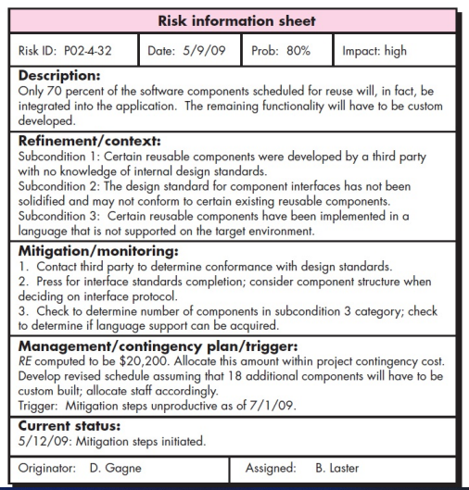

**Implementation:**

1. **Known Risks:**
   * **System Downtime:** This is a well-known risk in software engineering. Known risks could include server outages, software bugs, or infrastructure failures that may lead to system downtime, causing delays in order processing.
   * **Supplier Delays:** Known risks can involve delays from suppliers or vendors who may not meet their promised delivery schedules, affecting the order system's reliability.
   * **Inventory Management:** Issues like overstock or inventory shortages are known risks. Software should be able to manage and notify users about these inventory issues.
2. **Unknown Risks:**
   * **Emerging Technology Disruption:** New technologies or disruptive innovations in the industry, such as blockchain for supply chain management, could pose unforeseen challenges that the software engineering team may not be prepared for.
   * **Regulatory Changes:** Changes in international trade regulations or taxation laws affecting cross-border shipments might be unknown risks that can impact the order system.
   * **Market Shifts:** Unexpected changes in consumer preferences, like a sudden surge in demand for eco-friendly products, may introduce unknown risks to the system.
3. **Predicted Risks:**
   * **Cybersecurity Threats:** Predicted risks could include an expected increase in cybersecurity threats such as DDoS attacks or data breaches targeting the order processing system. Software engineers can proactively enhance security measures.
   * **Shipping Cost Fluctuations:** Anticipated fluctuations in shipping costs, perhaps due to fuel price changes or geopolitical events, can be predicted risks that impact the software's cost estimation and optimization algorithms.
   * **Supply Chain Disruptions:** Predicted risks might include labor strikes, natural disasters, or geopolitical instability affecting the supply chain. Software engineers can prepare for these by building in contingencies.

**Conclusion:**

In conclusion, risk management and analysis in software engineering are integral processes that play a crucial role in the successful development and deployment of software systems. By identifying, assessing, and mitigating potential risks, software teams can proactively address issues before they become critical, ultimately leading to more efficient and reliable software projects. These practices help in delivering high-quality software that meets user requirements, stays within budget, and adheres to timelines. Furthermore, as the software development landscape evolves with emerging technologies and changing user needs, the importance of robust risk management and analysis continues to grow, ensuring adaptability and resilience in the face of uncertainty. It is imperative for software engineering teams to embrace and prioritize these practices, as they ultimately contribute to the overall success and competitiveness of software projects.

Top of Form